**AI IN FRAUD DETECTION**

**Dhruvi Ranwala**

**Date: 21-08-2023**

**Abstract:**

*With the rapid growth of e-commerce and online transactions, the threat of online payment fraud has become a significant concern for businesses and consumers alike. The use of sophisticated fraud detection systems has drawn much interest as a means of addressing this increasing challenge. An overview of such an idea that uses machine learning is what I will be talking about.*

*My business concept involves an online payment fraud detection system that employs modern machine learning techniques are being used to combat the growing problem of such frauds. This technology quickly detects fraudulent transactions in real-time by combining deep learning methods, supervised and unsupervised learning methods, and machine learning.*

*A variety of transaction data, such as user profiles, transaction histories, device details, and behavioural patterns, are collected by the system. The system computes risk scores for transactions using Support Vector Machines (SVM), Random Forests, KNN Classification, Decision Tree classification, etc. improving detection accuracy by considering various viewpoints.*

*This business model offers organizations a flexible solution supported by machine learning that enables them to protect financial transactions and foster confidence in the digital sphere.*

1. **Problem Statement**

Concerns regarding the growing possibility of frauds have been raised as a result of the increasing popularity of online transactions. A quick solution that makes use of machine learning algorithms is urgently required in order to reliably identify these frauds in real time and promote a secure digital marketplace.

1. **Market/ Customer Need Assessment**

Due to the explosion in e-commerce and digital transactions, the market for solutions for detecting online payment fraud is growing quickly. The dangers connected with online payment fraud are being effectively reduced by businesses, financial institutions, and consumers alike. The following are the main customer and market needs that our Online Payment Fraud Detection System meets:

1. Real time monitoring:

To stop fraudulent operations before they do considerable harm, the capacity to monitor transactions in real-time is essential. By providing fast alerts for high-risk transactions and real-time risk assessment, the OPFDS enables organizations to react quickly and reduce possible losses.

1. Data privacy and compliance:

Businesses need a system that complies with compliance standards and data privacy laws as sensitive financial data is involved. In both its design and use, the OPFDS places a strong emphasis on data security and privacy.

1. Reduce false positives:

As vital as it is to find fraud, it's as critical to reduce false positives. To guarantee a favourable user experience, businesses need a system that can reliably discriminate between legitimate transactions and suspected fraud efforts.

1. Cost effectiveness:

A reliable method for detecting fraud can lessen operational disruptions and monetary losses brought on by fraud. By eliminating fraud and reducing the accompanying financial impact, the OPFDS offers a cost-effective solution.

1. **Target Specification and Characterization**

**Customer characterization of the Target Market:**

1. Businesses engaged in e-commerce, finance, gaming, and travel, among other sectors where internet transactions are essential.
2. Transaction Volume: Businesses that process a lot of online transactions need real-time fraud detection to stop losses.
3. Companies that place a high priority on data protection, customer trust, and legal compliance pose security risks.
4. Adaptability: Businesses seeking for scalable solutions that can change with their transactional patterns and business models.
5. Organizations who are receptive to adopting cutting-edge machine learning technologies to improve their fraud detection skills are said to have adopted technology.
6. User Experience: Companies that place a high priority on upholding a seamless and secure user experience, guaranteeing little interference with legal transactions.
7. Enterprises that understand the value of proactive risk management and seek to reduce financial losses resulting from online payment fraud.

In conclusion, a wide range of businesses and industries that want to strengthen the security of their online transaction, safeguard their clients, and uphold the integrity of their digital operations are included in the target specification and characterization for the Online Payment Fraud Detection System.

**Target Goals Achieved Through Analysis:**

1. E-commerce Platforms: Examining user behaviour and transaction patterns to

quickly spot anomalies and probable fraud in online transactions.

1. Financial Institutions: Making use of machine learning algorithms to examine transaction records and spot odd spending habits or unapproved account access.
2. Online Marketplaces: Using behavioural analysis to identify out-of-the-ordinary seller/buyer behaviour and assuring secure marketplace transactions.
3. Digital Payment Services: Investigating user profiles and transaction metadata to spot irregularities and fraudulent transactions in real-time.
4. Gaming and Virtual Goods Platforms: Tracking in-game trades and trading of virtual goods for patterns pointing to fraud.
5. Travel and Hospitality Services: Examining reservation data to spot odd travel trends and possible fraudulent reservations.
6. **External Searches:**
   1. **Benchmarking Alternating Products:**

*Product:* *Existing fraud detection solutions*

The company is well established and may provide a variety of features, possibilities and solutions tailored to industries.

Limited ability to respond to new threats and false positives can occur as fraud strategies change quickly.

*Product: Behaviour analysis platforms*

The capacity to spot anomalies, and flexibility in response to shifting fraud schemes is a great emphasis on user behaviour patterns.

Less effective in real-time detection, chances to produce false positives as a result of changes in user behaviour.

*Product: Cloud based fraud detection solutions*

Real time updates, scalability, accessibility, and seamless integration with cloud-based services.

Problems with data security, reliability on internet connections, and possible delays.

* 1. **Applicable Patents:**
* <https://patents.google.com/patent/US5819226A/en>

The technique and system described in the patent US5819226A served as the model for later, more sophisticated methods for detecting credit card fraud. With a focus on pattern identification, deviation detection, and learning from fresh data, it takes a proactive stance against the difficulties of credit card transaction fraud detection.

* The technique and system described in the patent US20180340377A1 uses geolocation data to enhance fraud detection. This method improves the precision of spotting fraudulent activity by providing an additional layer of context to transaction analysis, especially in the dynamic environment of distant and online transactions.
  1. **Applicable Constraints:**
* Data Privacy and compliance regulations
* Accuracy and False Positives
* Real time Processing
* Data quality and integration
* Adaption to new fraud patterns
  1. **Applicable Regulations:**
* Data protection and privacy regulations (Customer)
* Payment Card industry Data Security Standard (PCI DSS)
* Anti money laundering Regulations
* Cybersecurity regulations

1. **Business Opportunity:**

As online transactions and digital commerce increase, the market for my business idea is expected to expand significantly.

Businesses from a variety of sectors are looking for solutions to secure their final transactions and safeguard their consumer data, including those in e-commerce, gaming, and more.

This idea may position itself as a key partner in guaranteeing secure and reliable digital transactions by taking advantage of the increasing need for online payment fraud detection systems. Creating an innovative and flexible OPFDS that integrates cutting-edge technology with regulatory compliance will not only meet a pressing market need but will also give businesses a substantial competitive edge in the rapidly changing online commerce environment.

1. **Final Product Prototype:**

The suggested product is a service designed exclusively for small businesses that makes use of Market Basket Analysis, more specifically the Association Rule Mining technique, to offer insights on product bundling and marketing tactics to increase sales. The program uses transaction data analysis to find links between items, providing helpful suggestions to boost cross-selling and overall income.

* User Onboarding will require businesses to upload their transaction dataset.
* These will be then first cleaned and transformation of raw data into a suitable format for analysis.
* These are then analysed to identify rules of association.
* Highlight the system’s compliance with data privacy regulations and focusing on user consent mechanisms.

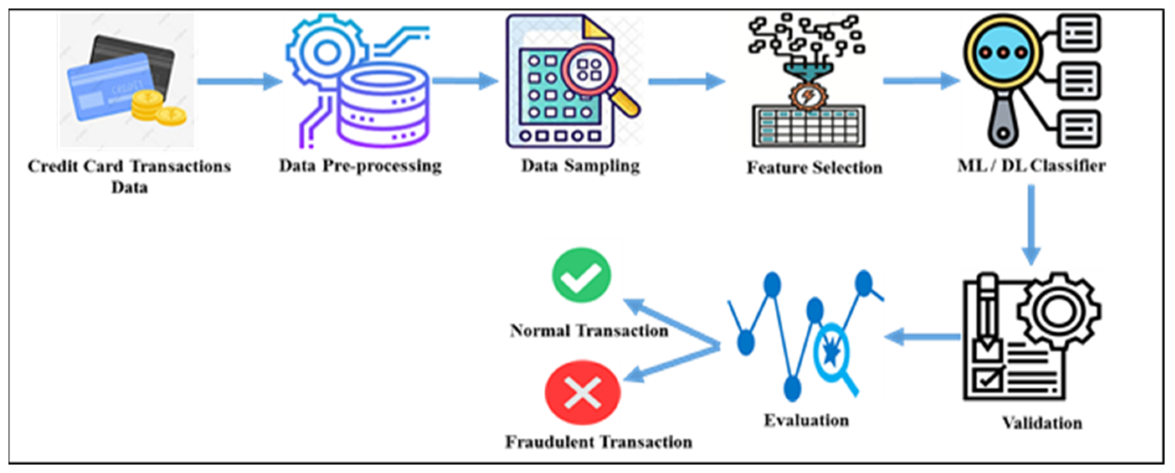

1. **Conclusion:**

The significance of protecting financial transactions cannot be emphasized as organizations rely more and more on online transactions. With its alignment with the changing requirements of a digital-first economy, the Online Payment Fraud Detection Solution emerges as a beacon of confidence and security. This solution is proof of the ability of technology to safeguard, reassure, and improve the online payment ecosystem by avoiding fraud in real-time, reducing false positives, and maintaining user privacy.